INCIDENT TYPE: | DATE/TIME REPORTED:
Aggravated Sexual Assault of a Child | 04/08/2020 at 1500
INCIDENT NUMBER: | LOCATION:
20BU006730 | Burlington, VT
INVESTIGATOR: | INVESTIGATOR CONTACT:
Detective Elizabeth Learned | 802-652-6899
AUTHOR: | APPROVED BY:
Det. Sgt. Brian LaBarge | Det. Sgt. Brian LaBarge
SUSPECT: | AGE: | SUSPECT ADDRESS:
William E. Cornelius | 48 | Colchester, VT
SUSPECT DISPOSITION:
Released on a citation and court conditions by the Judge pending his arraignment tomorrow

On 04/08/2020 the Chittenden Unit for Special Investigations (CUSI) was contacted by the Department of Children and Families (DCF) regarding a report from a parent concerning Mr. William Cornelius inappropriately touching their daughter. As a result, CUSI Detectives and a DCF Family Services Worker were assigned to investigate this report.

This afternoon CUSI Detectives located and interviewed Mr. Cornelius. Mr. Cornelius was subsequently arrested, processed and released on a citation per a Judge’s order pending his arraignment tomorrow on charges of aggravated sexual assault of a child in violation of Title 13 V.S.A. 3253a(8).
A person guilty of the crime of aggravated sexual assault of a child shall be imprisoned for not less than 25 years with a maximum term of life, and, in addition, may be fined not more than $50,000.00. The 25-year term of imprisonment required by this subsection shall be served and may not be suspended, deferred, or served as a supervised sentence. The defendant shall not be eligible for probation, parole, furlough, or any other type of early release until the expiration of the 25-year term of imprisonment.
During this investigation it was also determined that Mr. Cornelius was previously in a relationship with an individual who was a licensed and registered foster parent with DCF from 2001 until April 2010. During this time Mr. Cornelius also became a registered foster parent and would have had contact with foster children.
If you or someone you know has been a victim of sexual assault, there is support available. Even if the assault did not happen recently, there are resources to help you decide what is best for you, including free medical treatment, advocacy and support. You don’t have to go through this alone. There is a whole community ready to support you. For more information, call the state-wide confidential hotline, 800-489-7273, or see the website for the VT Network against Sexual and Domestic Violence, www.vtnetwork.org.

Thank you,

Detective Sergeant Brian LaBarge

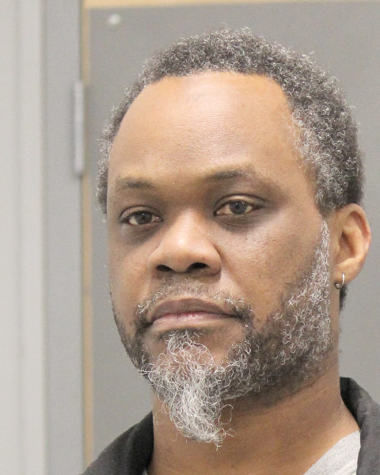
Mr. William Cornelius

