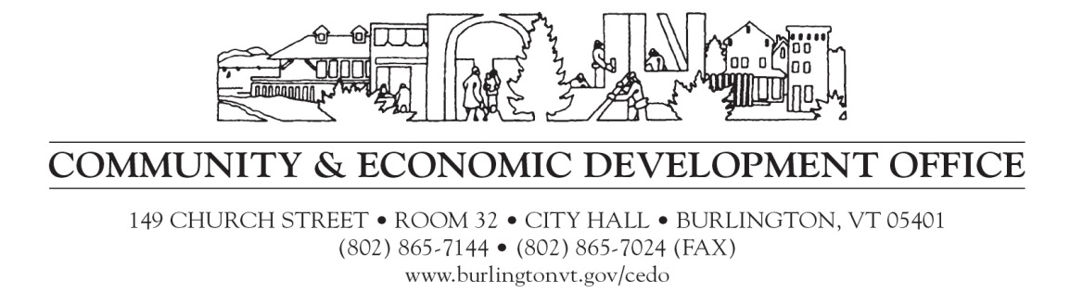

**Memorandum**

**To**: All Interested Agencies

**From:** Community and Economic Development Office, City of Burlington

**Date:** Thursday June 23rd , 2016

**Re:** Participation in Equity and Inclusion Training and Seminars 2016-2017

CEDO invites non-profit organizations, educational institutions, city and state agencies and mission driven businesses interested in participating in a CEDO hosted equity and inclusion training program to submit an application for the 2016-2017 program year. Please submit application electronically by July 12th, 2016. For more information or any questions please contact: Marcella Gange Program Coordinator, CEDO. [mgange@burlingtonvt.gov](mailto:mgange@burlingtonvt.gov)

**About the Program**

The goal of our Program is to provide the tools and resources for organizations to become more inclusive workplaces and better serve our diverse community. We support the cultural competency knowledge, skills, and awareness of staff, volunteers and board members in your organization; so you become more inclusive community partners.

**Participating Agencies:**



Over six years, we have provided training and coaching to hundreds of leaders, representing 40 organizations, schools and City departments. TheProgram partners with a highly skilled consultant team providing coaching and training to participants. In 2016-17, we will continue to support our longer term member agencies and their maturing needs, and bring new agencies into their first-year of the program. In doing so, we continue to create and support a broad foundation of positive communication, understanding and interaction across Burlington and beyond.

**The 2016-17 package to support your organizational change includes:**

* Strategic planning, assessment, and skills training for each organization’s Cultural Competency Team.
* A series of full and half-day retreats and small group coaching sessions to develop awareness, skills and strategy to achieve your organization’s equity goals. Retreats also facilitate a rich learning network among the participating agencies.
* Coaching session for your Cultural Competency teams, to support and focus teamwork.
* One day We All Belong Introductory Sessions, for any staff or board member or volunteer new to your organization’s Cultural Competency work.

**2016-2017 Program Details:**

**Strategic Planning for Change – Foundations. Two full day and one half day retreat to develop awareness, skills and strategy to achieve your organization’s equity goals.** Two of the trainings will focus specifically on the book Switch: How to Change things when Change is Hard by Chip and Dan Heath, and how to apply the book’s change strategies to the task of increasing cultural competency in organizations. The group will discuss and analyze strategies with proven positive effects, and consider what is, or is not, working in their own organization. In addition, utilizing strategies from the book, each organization will generate an action plan that will serve as a road map over the next year.

**Equity and Inclusion Seminar Series:** **Three ½-day customized trainings** to develop awareness, skills and strategy to achieve your organization’s equity goals. Retreats focus on select cultural competency topics: increasing personal awareness, understanding organization culture and strategic planning tools. In the past, seminars have explored the history and concepts of race and culture, considered gender and the historical roots of contemporary and institutional heterosexism, and suggested and practiced tools for difficult conversations related to race and racism. Trainings are cumulative; designed for your entire Cultural Competency team (ED, Staff, Volunteers, and Board Member).

**Professional Learning Community –** The cohort model facilitates a rich network across participating organizations. Learn from what other teams are trying, learning and what they’ve learned when efforts were not successful. WAB will support information sharing with a variety of online tools.

**Participating agency requirements:**

* Participation is based on the commitment of your organization to create a more inclusive workplace and provide more equitable and culturally relevant services.
* Maintain an internal cultural competency team to oversee this work, to be composed of the CEO, a board member, and representation of staff. The team is expected to meet monthly in addition to seminars.
* Cultural Competency Team fully participates in cultural competency retreats and coaching sessions.

**Costs**

We All Belong is funded through contributions from each participating organization. Each organization pays a *training fee* scaled according to your organization’s budget (see table below). There are a limited number of scholarships available; please include a paragraph in your application stating your need and amount of scholarship requested.

**Participation Fees**

|  |  |
| --- | --- |
| **Training Fee Scale by Organization Budget** |  |
| < $1,000,000 | $3,200 |
| $1,000,000-$2,000,000 | $5,000 |
| > $2,000,000 | $6,500 |

**Who Should Apply?**

The ideal applicant aspires to grow your organization to better serve and reflect Vermont’s

demographic diversity. Applicants demonstrate a clear desire for organizational growth and change. We provide tools for assessment, planning and the platform for organizations to create sustained changes. We are seeking organizations ready to make, at a minimum, a **one-year commitment** to the program with the expectation that systems-level change is a multi-year endeavor.

**Definitions and Resources**

**A Working Definition of Cultural Competence**

Cultural competence is a developmental process that evolves over an extended period. Both individuals and organizations are at various levels of awareness, knowledge and skills along the cultural competence continuum.

Cultural competence includes:

* Having a defined set of values and principles, and demonstrate behaviors, attitudes, policies and structures that enable organizations to work effectively cross-culturally;
* Having the capacity and commitment to (1) value diversity, (2) conduct self-assessments, (3) manage the dynamics of difference, (4) learn about and institutionalize cultural knowledge and (5) adapt to diversity and the cultural contexts of the communities organizations serve; and
* Incorporating the above in all aspects of policy making, administration, practice, service delivery and systematically involving constituents, key stakeholders and communities.

Cultural competence also incorporates a social justice perspective and includes:

* Recognizing and understanding the impact and influence of personal, institutional, and cultural dynamics of power and privilege;
* Understanding the larger social context and systems and their impact on people’s lives and interpersonal/group behaviors; and
* Practicing social justice values such as equity, respect, fairness, cooperation, and shared responsibility.

Adapted from the National Center for Cultural Competence at Georgetown University definition [http://www11.georgetown.edu/research/gucchd/nccc/](https://mail.ci.burlington.vt.us/owa/redir.aspx?C=27a84ad40b864e51b2c4237d9fc1a298&URL=http%3a%2f%2fwww11.georgetown.edu%2fresearch%2fgucchd%2fnccc%2f)