235 Penny Lane
S. Chapin Spencer P.O. Box 878
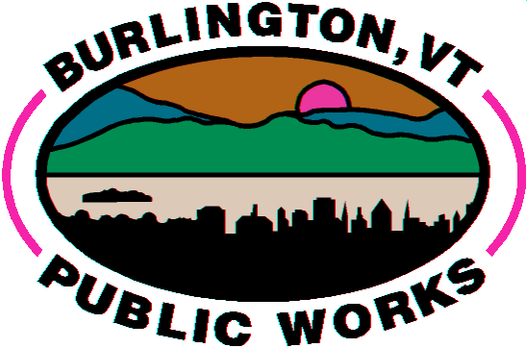
Public Works Director Burlington, VT 05402
Megan Moir (802)863-4501 Phone
Assistant Director (802)864-8233 Fax www.burlingtonvt.gov
water-resources@burlingtonvt.gov

PROPERTY MANAGER AGREEMENT FORM

ONLY PROPERTY OWNERS ARE AUTHORIZED TO FILL OUT AND SIGN THIS FORM

Property Owner(s) Name: Click here to enter text.
Full Mailing Address: Click here to enter text.
Phone #: Click here to enter text. Email Address: Click here to enter text.
Water Account #: Click here to enter text. Service Location: Click here to enter text.

We have received a request to allow your property management firm to do business on your behalf as related
to the Water Resources bill for the above listed property. Please be aware that the Burlington City Ordinances
(section 31-19) state "Although another person may pay the service rate, the owner of the premises shall
be held responsible for such rate." This means if your property manager (or any tenants they authorize) fails to
pay the bill then we will hold you liable for the balance.

- As the property owner your name will remain on the bill at all times and the property manager is listed as a care of (c/o). You will only receive statements concerning this account if the property manager fails to pay the bill, interest is assessed and the delinquency is $100 or higher. Please sign up for our online account monitoring, so you can stay informed about your property.
- This form in no way relieves you of responsibility for unpaid balances; see City Ordinance section 31-19.
- This form must be completed and returned before we can make any related changes to the bill.
- Completion of this form will grant your property manager authority to complete Tenant Agreement Forms on your behalf and receive the interest notifications if the tenant(s) fails to pay. You will not receive a copy of the interest notification under this circumstance.
- The property manager will remain on the account until we receive notice (verbal or written) of removal or another completed authorization form is received.
- If no current property manager form is on file then the mailing address reverts back to you.
- We do not provide final bills upon termination of contracts with property managers or leases with tenant(s). It is the responsibility of the property owner to inquire about any unpaid balances and we strongly encourage verifying account status prior to closing joint bank accounts or returning a security deposit.

I HAVE READ THE ABOVE AGREEMENT AND UNDERSTAND THE WATER RESOURCES BILL WILL REMAIN
MY RESPONSIBILITY IN THE EVENT THAT MY PROPERTY MANAGER OR TENANT(S) DOES NOT PAY.

Owner(s) E-Signature: Click here to enter text. Date: Click here to enter a date.

I would like the bill to go to: Click here to enter text.
At the following mailing address: Click here to enter text.
PM Email: Click here to enter text. Effective date: Click here to enter a date.

