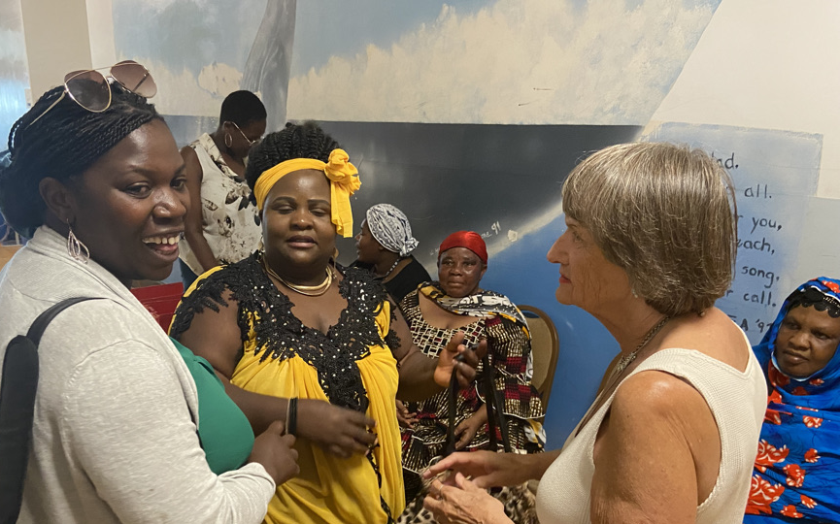
www.carolinefundvt.org

People’s Legal Services and Education Program

Proposal

Prepared for: Burlington City Government
Prepared by: Eric Agnero, Development Coordinator, The Caroline Fund
April, 25th 2023
Proposal number: BVT-001

the People’s Legal Services and Education Program (The program)

Executive Summary

Significant numbers of people living in the City of Burlington and surrounding communities face serious challenges in accessing justice. The Burlington Area has a growing BIPOC population, including many refugees and immigrants. The legal needs of this community, particularly the needs of women of color, poor women, mothers and their children, are not being well met by the traditional providers of legal services. For the past year, The Caroline Fund Sandy Baird Esq. has provided legal services on an ad-hoc basis to this population in collaboration with the AALV (formerly the Association of Africans Living in Vermont). In response to these challenges, the People’s Legal Services and Education Program is designed to:

- Institutionalize and make permanent a Program delivering legal services to unserved and underserved members of the Burlington-area community, with a particular focus on the needs of women and their children , and
- Ensure that New Americans, refuges, the BIPOC community, low-income women, and other marginalized populations have access to legal services and access to the justice system, especially in the Family Courts and
- Strengthen and deepen educational and cultural opportunities for the above-described community thereby enabling them to become more engaged and better-informed citizens.
- The Center would partner with other organizations such as AALV and will ensure maximum impact, while avoiding redundancy and duplication of effort, by collaborating with other organizations operating in the legal services/community justice, and educational sector.

For the year 2024, We intend to provide:
- legal service for more than 40 clients
- organize and least 4 Community Education Events.

The total funding need or 2024 is $ 100,000. The Caroline Fund will provide $50,000, and the expected funding from Burlington City is $ 50,000

The Caroline Fund
The Caroline Baird Crichfield Fund was founded in 1998 when Caroline Crichfield, an African- American daughter of Sandy Baird and Grant Crichfield was murdered by her domestic partner. The Fund has two missions: to help women and their families with emergency funds to meet the needs of these families in crisis; and, to help support and develop projects like the People’s Legal Services and Education Program which assist women and their families to live safe, creative and free lives.
This Burlington-based nonprofit organization supports women and their families in emergency situations. The Fund also endeavors to offer free legal advice to anyone seeking guidance. It is envisioned that the Caroline Fund would be the overarching organization of Center and would underwrite/contribute to the activities of the Center.

Background and Rationale

- Legal services and immigration counseling are currently provided by AALV and The Caroline Fund. However, the demand for these services far exceeds the resources available.
- The efforts of The Caroline Fund and Sandy Baird, in partnership with AALV, to staff a Legal Clinic and provide free legal advice and all legal assistance to marginalized individuals are not sustainable as most of that work is provided on a low bono(reduced fees) or pro bono( free) basis.
- There are gaps in legal services provided by Vermont Legal Aid. Services are not provided for issues related to family law and involving Family Court, including divorce, child custody, parentage, domestic violence, and child support. Gaps also exist in the provision of legal services related to immigration and asylum, the problems connected with landlords and tenants, some criminal matters and the expungement of criminal records.
- The legal services provided by AALV and the Legal Clinic are a “last resort” for most current beneficiaries.
- Funding is required to help people seeking legal advice and legal services especially tn the Family Courts.

Overall Goal

The aim of the People’s Legal Services & Education Program is to provide access to the justice system for our community’s most vulnerable through the provision of no-cost and low cost legal services.

Specific objectives of the People’s Legal Services and Education Program are:
- Enhance the capacity of the AALV to better serve New American and refugees.
- Provide needed legal services and advice to all marginalized people irrespective of their race, sex, ethnicity, and income.
- Identify and recruit lawyers with the experience and expertise required to serve the targeted beneficiaries of The Center.
- Link individuals volunteering for The Center with individuals requiring support and assistance.
- Better coordinate the delivery of legal services to New Americans, refugees, poor and low income people, and other marginalized populations.

Expected Results

The Program is expected to:
- Provide advice and free and low fee legal assistance to individuals and families, and community members
- Organize at least 4 Community Education Events

Approach,Governance/Partners/Collaborators

Governance
The Caroline Fund would be the overarching organization of the program and would underwrite/contribute to the activities of the program. The Caroline is a non-profit, Board governed, volunteer organization in existence since 1998 funded by donations from those who are committed to the two missions.

Partners
The Program would partner with other organizations, some of whom include:

- AALV-The Program will be embedded in the Burlington-offices of AALV. AALV, a nonprofit organization located in the Old North End Community Center, helps New Americans from all parts of the world gain independence in their new Vermont communities. The range of integration services include case management for refugees, behavioral health awareness, workforce development, and interpretation. Limited legal services are also provided.

- The Vermont Institute for Community and International Involvement-VICII is a nonprofit educational organization based in Burlington with a vision to build a vibrant and just community with engaged citizens through dialog, education, debate, discussion, and friendship. VICII would continue to support educational programs aligned with the Center’s mission. The Paralegal Program and the Law Clerkship Program are currently programs of VICII. These activities will become part of the People’s Legal Services and Education Program.

- The People’s Law School-Launched by Vermont’s Attorney General T.J. Donovan in March 2021. The People’s Law School provides a series of free presentations on contemporary topics impacting the lives of Vermonters. In 2021 practical information was provided on a range of topics, including: the Fourth Amendment, representing yourself in Small Claims Court, tenant rights, understanding eligibility for public benefits, and family law. The program is an evolving project with AALV, the Vermont Racial Justice Alliance, and the VICII and The Caroline Fund. The People’s Law School would serve as a core educational component of The Program

Collaborators
The Program will ensure maximum impact, while avoiding redundancy and duplication of effort, by collaborating with other organizations operating in the legal services/community justice sector, including:
- Vermont Legal Aid
- Legal Services Vermont
- Vermont Volunteer Lawyers Project
- Vermont Bar Association
- Vermont Law School
- Chittenden County State’s Attorney Office
- Community Justice Centers
- Catholic Legal Immigration Network
- Attorney General’s Office
- STEPS (formerly Women Helping Battered Women)

Company Name

Budget

The budget for the People’s Legal Services and Educational Program will be modest and is currently projected to be approximately $100,000 in the first year of operation. The most significant expense relates to the hiring of a Coordinator for The Program. Lawyers providing services will serve as volunteers, providing pro/low-bono services. The program is run by the Caroline Fund with AALV providing the space and utilities required.

Total Budget Description

Description | Quantity | Unit Price | Cost
Legal services to individuals | 40 | $2,000 | $80,000
Community Education Events | 4 | 5,000 | $20,000
Total |  |  | $100,000
Expected Funds from Burlington City |  |  | $50,000

