The Office of Racial Equity, Inclusion, and Belonging (REIB)
Embrace & Belonging
The mission of the Racial Equity, Inclusion, and Belonging (REIB) office is to safeguard the accessibility, equity, and belonging of BIPOC residents using the tools of government. The inalienable rights of life, liberty, and the pursuit of happiness have yet to be actualized for many historically disenfranchised groups. Although there is no fix for systemic harms such as slavery, there is remediation in which we mobilize equity, inclusion, and belonging by addressing racialized behaviors that have and continue to disproportionally harm BIPOC residents. By doing so, we can build a Burlington in which all citizens are afforded the opportunity to fully embrace the everyday joys of life.
To this effect, some highlights from FY 22 were:
- Food Insecurity Program: As part of the ongoing Eight-Point Plan to protect BIPOC Communities and Ensure a Racially Just Recovery, the REIB provided $92,500 in food aid to support over 500 households.
- Cannabis Retail Policy: In partnership with the Business and Workforce Development department, the REIB advised City Council on the City’s cannabis retail policy resulting in local option sales tax revenue to be devoted to the City's equity goals.
- Supplier Diversity Program: The City of Burlington hired an Economic Equity Analyst to create partnerships across public, private, and non-profits to collaboratively produce innovative solutions for the racial wealth gap.
- Reparations Task Force: Reparations experts generated four reports to support the task force’s work to conduct a reparations study in Burlington.
- Juneteenth Celebration: Our 2nd annual Juneteenth event brought the community together and welcomed both national and local artists and vendors to continue to build on Burlington’s legacy of commemorating Juneteenth and uplifting and celebrating the Black community.
- Education: The office facilitated training for 400+ staff across municipal offices.

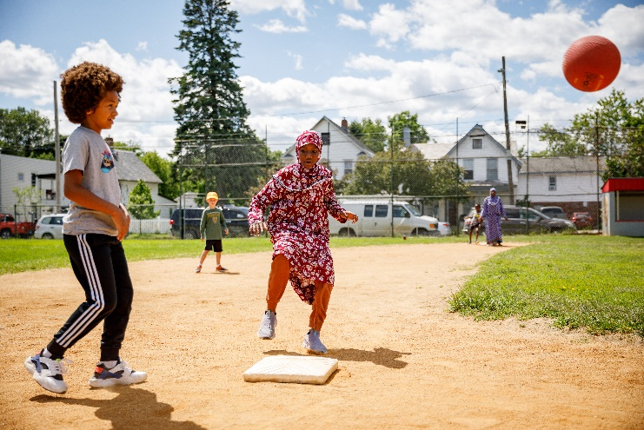
In FY 23, Director Kim Carson continues to move the work forward following the leadership change of the office. She was appointed to the role on November 8th, 2022 moving her family from Iowa where she was the Director of Education and Human Capital Development for the Iowa Judicial Branch with over 20 years of work impacting disparities for marginalized and historically disenfranchised populations. We thank all who have welcomed her in this transition that ushers in a new era for this office and honor the groundbreaking work that established it as the first of its kind within the municipality.
As we move through FY 23, the priorities are to continue moving the city forward by operationalizing and implementing the City of Burlington's Racial Equity Strategic Roadmap over a multi-year strategic development process. What began as five identified areas of focus – economy, education, health, housing, and justice – will be expanded into the domains upon which our office will be structured:
- Economy
- Health
- Social and Human Development
- Physical Environment
- Community and Belonging
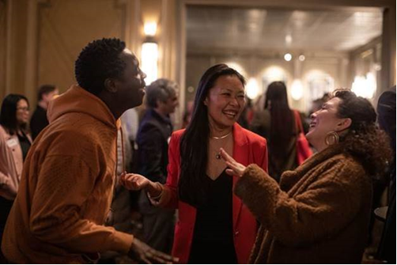
These efforts will be supported by realigning the office’s funding beyond temporary American Rescue Plan Act (ARPA) dollars, which are primarily the office’s current funding source, to a hybrid between the General Fund and other funding sources to sustainably integrate the office into the municipality’s operational structure. Currently, our FY 23 Budget is 60% funded through federal ARPA funds. Looking forward to FY 24, ARPA funding will decrease by half as we prioritize creating sustainable staffing positions funded from the City’s General Fund.
We move forward into FY 23 with the mission of ‘Minding the Gap’ between community and institutions to ensure restorative action of historical inequities and systemic disenfranchisement within municipalities, leveling the playing field for all. This process includes:
Mobilize | Analyze | Leverage | Institutionalize | Evaluate
Community voices and experiences to inform and direct identification and planning | Data, community input, outcomes, and programs for effective decision-making | Resources, evidence-based best-practices, human capital, and historical precedent | Policy, procedure, practice, and props | Progress and outcomes to inform adjustments
Throughout, we are committed to reimagining policies and practices and informing programming in a way that empowers community voice and is founded in partnership with the public, stakeholders, community leaders, and public officials alike. As we move forward, a glance at some of our highlighted priorities
- Continued Strategic Roadmap Development: As we move forward with a new and aligned mission and vision, we will continue addressing inequities through the lens of our Racial Equity Strategic Roadmap. These specifically include building out our team across the five domains in order to meet the goals outlined in the roadmap.
- REIB Website & Application: The office is updating our website and will be launching our app in 2023! These platforms will share important data, events, policies, and more to increase awareness of our work and provide publicly available tools for the community.
- Leading the Task Force on Increased Community Violence: The director will chair the task force that will address recent violent incidents and their root causes. This collaboration includes community forums with mental health professionals, relationship development between community leaders and city officials, and a youth engagement initiative to ensure youth voice is central to the discussions around public safety
- Continued Work on Reparations Task Force: Move forward on the work from the Task Force from the research and analysis face to drafting proposed remediation.
- Landmark Sculpture Project: The office in collaboration with the community, BCA, and BPRW has commissioned a sculpture named Embrace & Belonging which will be unveiled in Dewey Park in June of 2023.
- Racial Equity, Inclusion, and Belonging Focused Education: Building on our strategic partnership with HR, we will work towards designing and implementing a strategic process to provide intentional professional development for municipal staff from recruitment to separation.
- Homeownership Policy: In collaboration with internal and external partners, we're conducting an ongoing assessment of historical disenfranchisement in home ownership in Burlington, and designing a process to address these barriers in a timeline that works most effectively within market trends.
- Business Registry: In partnership with the Business & Workforce Development department, we building a BIPOC business registry in an effort to highlight specific groups, increase contracting opportunities, and develop a more robust and diverse supply chain.
Since the inception of this office, the lessons learned have been extensive and our breadth of responsibilities have followed suit. We must now, more than ever, continue to be vigilant to ‘Mind the Gap’ while we strive to reckon with and remediate the unquantifiable harm of the trans-Atlantic slave trade, indigenous genocide, and all other fruits from the poisonous tree.
As we continue to build on the investments made by this vibrant and evolving community, we ask you to remain steadfast in our shared responsibility in actualizing the full potential of our Queen City.

